**Assignment 1 – Sum of Numbers**

Create an application that displays a form as shown below.

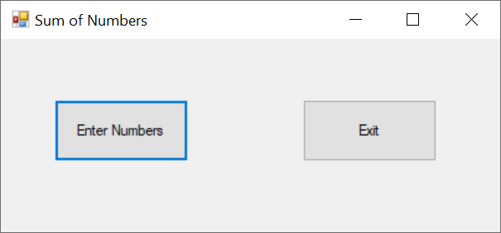

When the Enter Numbers button is clicked, the application should display an input box like this;

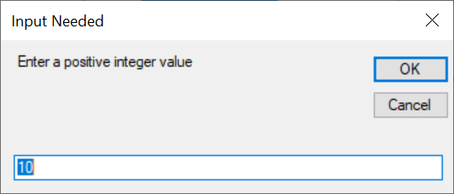

The input box asks the user to enter a positive integer value. Notice that the default value is 10. When the OK button is clicked, the application should display a message box with the sum of all integers from 1 through the value entered by the user, as shown here;

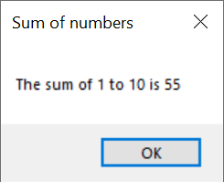

If the user enters a negative value, the application should display an error message and not provide an output. Make sure you have comments in your program explaining what you are doing. Also make sure you test your program prior to submitting. Use the following test data to make sure your application is working correctly.

Value Sum

5 15

10 55

20 210

100 5050